2015 Asia Sub-Group Meeting of the Paddy Rice Research Group
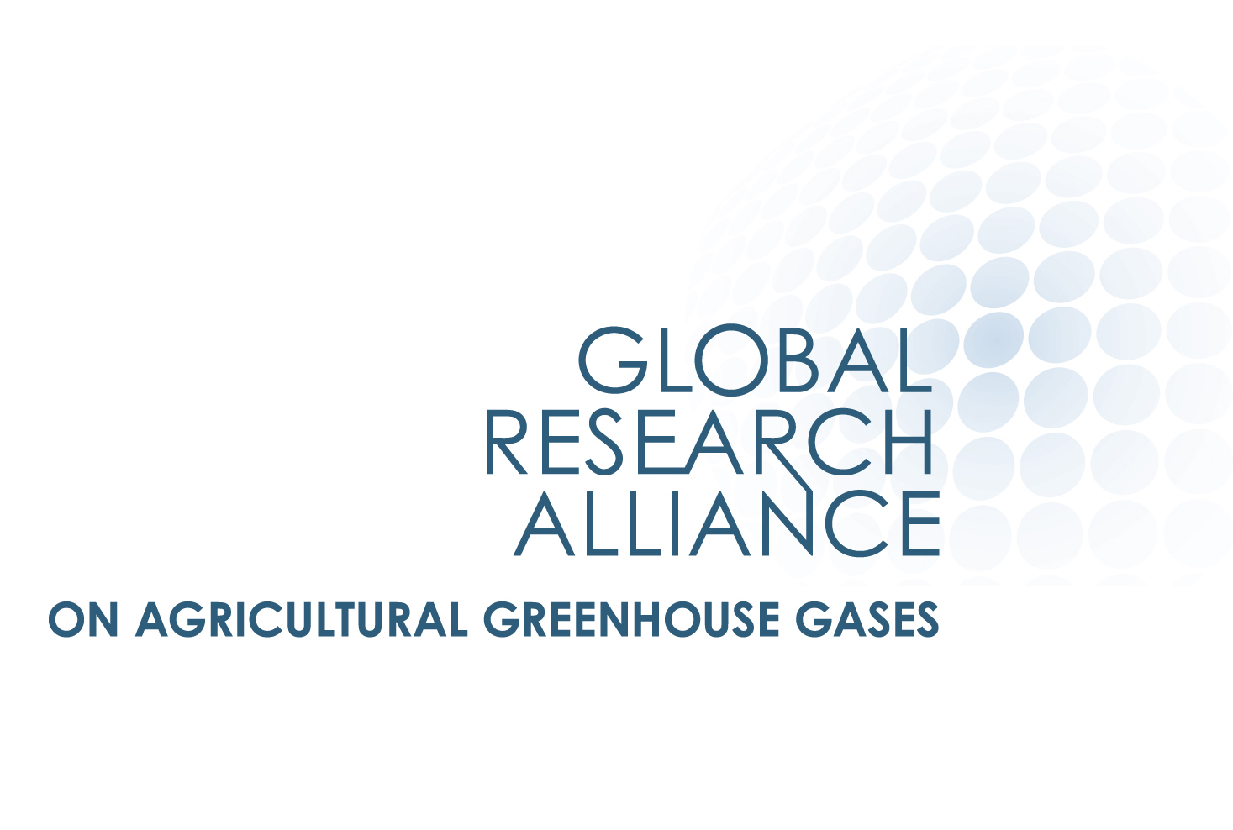

18 September 2015

Institute of Soil Science, Chinese Academy of Sciences, Nanjing, China

AGENDA (provisional as of 24 June 2015)
Venue: Institute Meeting Room (to be confirmed)
Time | Session | Presenter / Moderator
0830 | Opening:  - Welcome addresses | TBD
0840 | Overview of the Alliance:  - Review of Council meeting (Des Moines, June 2015)  - Other Research and Cross-cutting Group activities  - Upcoming milestones | Alliance secretariat
0900 | Overview of the Paddy Rice Research Group (1):  - Review of activities in the Group  - Review of Agenda and Objectives of the meeting | PRRG Co-chair
0920 | Participants’ self-introductions:  - With brief introduction to research updates | Participants
1000 | Coffee break
1030 | Overview of the Paddy Rice Research Group (2):  - Review of activities in the Americas Sub-Group | PRRG Co-chair
1050 | Action Plan discussion (1):  - Standardisation of measurement techniques  - Databases for experimental sites  - The pilot multi-site/country experiment | Japan
1200 | Lunch
1330 | Research Activity Report (1):  - Methane mitigation research in China | Institute of Soil Sciences, CAS, China
1400 | Research Activity Report (2): | TBD
1430 | Action Plan discussion (2):  - Mitigation and adaptation synergies  - Rice cultivar initiative  - others | Vietnam, Indonesia, others
1500 | Coffee break
1530 | Action Plan discussion (3):  - continued
1630 | Future activities:  - Next steps to implement the Action Plan  - Upcoming milestones | PRRG Co-chair  Alliance secretariat
1730 | Meeting close

