Information on Climate and Agriculture of Azerbaijan
International Cooperation on Climate Change
Azerbaijan approved the United Nations Framework Convention on Climate Change (UNFCCC) in 1995, and the Kyoto Protocol in 2000. As one of the first additional non-member Partner of UNFCCC, Azerbaijan did not have quantitative commitments to reduce greenhouse gases. However, in order to participate in the Clean Development Mechanism of the Kyoto Protocol the institutional structure was improved and the State Commission on Climate Change, National Competent Authority on the Kyoto Protocol, and the Center for Climate Change and Ozone were established. Azerbaijan help developed countries to reduce its emissions by implementing CDM projects. Ministry of Ecology and Natural Resources prepared and approved the national registration, review, and approval procedures of CDM projects and assessment rules for the sustainable development of the country. Currently, six CDM projects as well as projects in the energy sector on the use of alternative energy and waste have been registered by the CDM Board. Two projects passed the validation process (oil and gas sector) and around 40 Project Idea Notes (PIN) covering different areas of the economy have been prepared. Approximately 19 million tons of CO2-eq of emission reduction annually is expected through these projects. Azerbaijan has regularly attended all the meetings and conferences on climate change.
Azerbaijan does not have a dedicated climate change strategy yet, but it has undertaken measures to support climate change efforts, such as the United Nations Framework Convention on Climate Change and the Kyoto Protocol. Azerbaijan has also prepared a number of laws, state programs, and regulatory acts concerning the Convention, and has adopted related international documents that support climate mitigation. Furthermore, Azerbaijan prioritized the use of alternative energy and the development of low-carbon measures in the commercial and residential sectors, and set a target to reduce carbon dioxide (CO2) emissions from 41.1 million tons to 32.7 million tons of CO2 by 2030.
GHG emissions
GHG reduction has to some extent already taken place in the country. Due to the decline in industrial activities since 1990, the level of GHGs released into the atmosphere from stationary and mobile sources in the country has declined. While the level of GHG emissions equated to 55.1 million tons of CO2 in 1990, in 2011 this figure accounted for 26.8 million tons of CO2 .According to the GHG Inventory prepared for Third National Communication Report(TNC), Azerbaijan’s annual GHG emissions were 50.6 million tons of CO2 eq/year in 2005. The energy sector, accounted for the largest share of domestic emissions, with a share of more than 50% of the emissions. The following figures show the dynamics of GHG emissions by sector and by GHG gas:

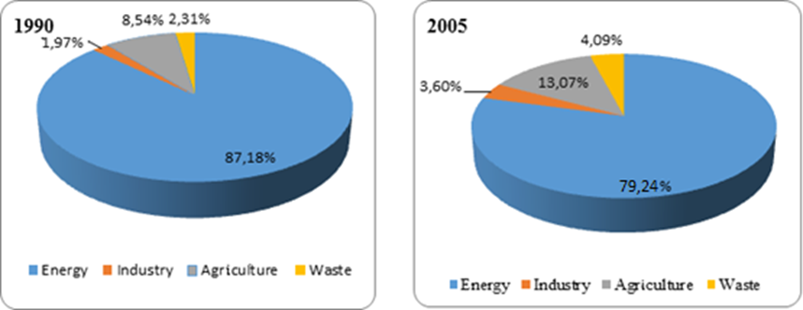
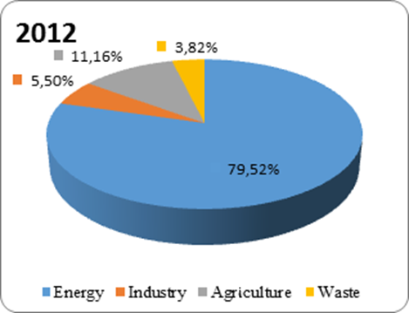
Figure 1. GHG emissions by sectors
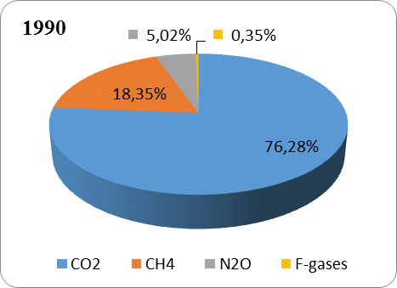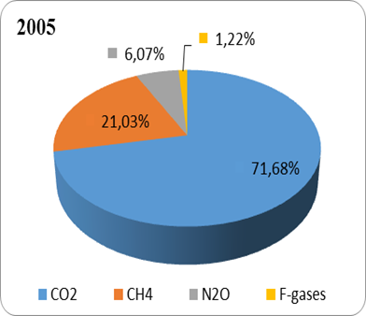
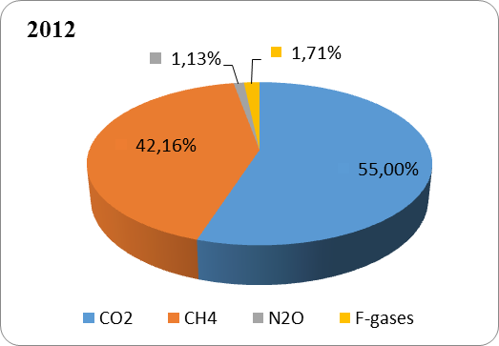
Figure 2. GHG emissions by gases

Land-use change and Forestry are the main CO₂ sinks, they show that the absorption of CO2 has increased from 3,690 in 1990 up to 5,442 Gg CO₂ in 2012. The net emissions decreased from 69,641 in 1990 up to 49,446 Gg CO₂ eq. in 2012. The rapid decline of GHG emissions was observed in the period of 1990-2000s and was about 35,904 Gg CO₂. This decline in GHG emissions was related to a decline in industrial activities during the first period and also due to the implementation of mitigation measures after the year 2000. But the economic boom and the growth of population is leading to an increase of CO₂ emissions, which is evidenced by the inventory results.
GHG emission trend in Azerbaijan (1990–2000-2010) GHG Source and Sink Categories | Emission base year – 1990, (Gg CO2 eq.) | 2000 Emissions (Gg CO2 eq.) | 2010 Emissions (Gg CO2 eq.) | Change from 1990 to 2010
Energy | 63.928 | 33.006 | 36.596 | -43%
Industry | 1.447 | 554 | 2.108 | +46%
Agriculture | 6.261 | 5.368 | 7.244 | +16%
Waste | 1.694 | 1.837 | 2.260 | +33%
Total Emission | 73.331 | 40.774 | 48.209 | -34%
LULUCF | -3690 | -4.870 | -5410 | +47%
Net emission | 69.641 | 35.904 | 42.779 | -39%

Agriculture sector
Agriculture plays an important role in the economy of Azerbaijan and 48% of the population lives in rural areas. Agriculture employs 38% of the country's population. Though favorable soil and climatic conditions of the country and a comparative advantage of traditional agricultural production, the agricultural sector provides less than 6% of the national Gross Domestic Product.

Bee-keeping and breeding of vegetables are the main sources of income for the rural population. Tourism activities are also an important source of income for some rural areas. Agriculture is a traditional economic activity in Azerbaijan. Historically, viticulture, silkworm breeding and fruit growing activities are traditional activities. The country is mostly mountainous, so cattle and sheep breeding is particularly important.

According to the climate change scenario (HadCM3 model and A1 scenario) a temperature increase of 1.5-2.0 ⁰C, and a 5% decrease in precipitation will be observed in the period of 2015-2050. According to the predictions from 2041-2070 the temperature will see an increase of 2.5-3.0 ⁰C and the precipitation will decrease by 10%. The following years (2071-2100) will see a temperature increase of 5 ⁰C and a 15-20% decrease in precipitation.
The observed increase of days with high-temperatures has led to droughts and has also reduced sharply the productivity of rainfed crops in some areas such as Shaki, Shamakhi and Gobustan. As a result of the 2014 drought, grain yields fell. In rainfed areas, mentioned above– a large part of grain fields were lost because of the drought, this is a serious future indicator. The unstable weather conditions are having a negative impact on tea planting in the southern regions.
The absence of irrigation opportunities in the rainfed areas during the dry season impedes the implementation of adaptation measures in these areas. The predicted droughts will have a negative impact on the productivity of viticulture. Viticulture takes places in foothills such as Shamkir, Dashkesen, and Gadabay. According to the HadCM3 model of A1 scenario, the temperature in these areas will also increase to 3⁰ C in 2041-2071, and precipitation will decrease 5-10%.

There might be a reduction in agricultural production because of the impact of climate change. For example, recent studies in different countries have shown that for 1⁰C increase in temperature productivity of cereals and legumes will decrease by 10%. Considering this, in 2030 the production in Azerbaijan will decrease by 10%, and 5-25% in 2070.

Agriculture plays an important role in food security and improving the socioeconomic situation of rural regions.The main adverse effects of climate change on agriculture have been identified as follows:
- Increase in temperature will cause the increase in the number of dry days (drought periods);
- Lack of irrigation water due to a decrease in precipitation;
- As a result of the break in the precipitation cycle, periods of excessive precipitation can occur, causing landslides, floods that leads to crop losses;
- Loss of productivity of agriculture products that are not drought-resistant (cereals, grapes, fruit crops, vegetable crops, etc.), particularly in areas of rainfed agriculture;
- Increase in the levels of summer and winter pastures degradation due to decrease in precipitation.
More than 80% of agricultural production in Azerbaijan is produced in irrigated areas. The lack of water in these areas, as the future models indicate, will have a significant impact on the productivity of agricultural crops. It could also cause food shortages. In order to reduce the impact of climate change in the irrigated areas, an efficient use of the water resources is required. Droplet irrigation systems are required to be used in gardening and vegetables growing, rainfed irrigation systems in cotton, forage crops, and cereals irrigation. Due to the high cost of these systems, farmers do not actively use these technologies. In order to increase farmers' interest in this area preferential term of the lease of these technologies and future subsidies should be given to farmers.

The more vulnerable areas to climate change in Azerbaijan are the rain fed areas. These areas are divided into moisture lands and non- moisture lands. There is a serious risk for crop production in the non-moisture lands. These areas will require special adaptation strategies to the impact of climate change. An accurate forecast for seasonal and annual precipitation, assessment of existing water resources, surface water management, covering the soil surface with crop residues for the maintenance of soil moisture and other measures have to be introduced in these areas. It is possible to build small water reservoirs, which can accumulate precipitation and to use this water for additional irrigation of agricultural crops in the dry times. The fight against erosion has to be kept in focus.

It is important to note that the local population and government bodies have low levels of knowledge about the negative effects of climate change and this causes an increase in vulnerability in this sector.

As a result of vulnerability analysis the agricultural areas more vulnerable to climate change were identified. The most important crops in the country are: cotton, fruits, grapes/viticulture, vegetable, and tobacco.
The agriculture sector is a main source of GHG gases as CH4 and N2O. Sources of GHG gases in agriculture are enteric fermentation, manure, rice planting, burning of agricultural residues. As a result of the activities in the agriculture sector, CH₄ emissions increased from 129 Gg. in 1990 up to 182 Gg. in 2012. The N₂O emissions in this period slightly decreased, due to the decrease in usage of fertilizers.
Azerbaijan’s main sources of emissions in the agriculture sector come from enteric fermentation, manure management, rice cultivation and land fertilizing. The emissions in the agricultural sector come from three sources:
- CH₄ release from keeping of domestic animals;
- CH₄ release from rice-cultivation;
- N₂O release from agricultural lands.
CH₄ release from breeding of domestic animals such as livestock is divided into two categories:
- Internal fermentation of agricultural animals;
- Manure management.
Methane is primarily separated from animal fermentation (85%). The rest (15%) refers to manure. As the rice cultivation areas cover a very small part of the country, methane emissions are very low, and not representative. In addition to this, rice production in the country has virtually stopped during recent years.
It should be noted that, due to the increase in the number of livestock in recent years has played a crucial role in the growth of methane (CH4) emissions. CH₄ emission has increased around 45% in the reporting year comparing to the base year. In 2012 in the manure area it has increased by 19.5 % compared to the 1990 values.
CH₄ emissions from rice production in 2012 were only 0.16 Gg. The burning of agricultural residues is also decreasing. The table below illustrates the evolution of the emissions in agricultural sector.
Source | 1990 | 2000 | 2005 | 2006 | 2007 | 2008 | 2009 | 2010 | 2011 | 2012
Enteric fermentation | 115,66 | 129,12 | 153,68 | 162,95 | 167,39 | 176,58 | 173,99 | 175,4 | 170,6 | 166,05
Manure management | 12,1 | 14,59 | 17,69 | 18,12 | 18,68 | 20,57 | 19,52 | 19,74 | 20,01 | 19,37
Rice cultivation | 0,05 | 0,45 | 0,23 | 0,12 | 0,11 | 0,13 | 0,17 | 0,16 | 0,16 | 0,16
Field burning of agricultural residues | 1,34 | 0,3 | 0,66 | 0,49 | 0,42 | 0,32 | 0,25 | 0,25 | 0,21 | 0,22
Total | 129,15 | 144,46 | 172,26 | 181,68 | 186,6 | 197,6 | 193,93 | 195,55 | 190,98 | 185,80
Table 2.5-1.CH₄ emissions from agriculture sector (in Gg.)

As the table shows, in general, the amount of methane emissions in this sector has increased compared to 1990 values. Reduction is only observed in the category of burning of agricultural residues.
For 2012 N₂O emissions in the agriculture sector have decreased by 11.8 % compared with the 1990 values N₂O emissions in manure management have increased by 55% compared to 1990, and N₂O emissions in agricultural soils have also decreased by 20% because of the decrease in the use of fertilizers.
Source | 1990 | 2000 | 2005 | 2006 | 2007 | 2008 | 2009 | 2010 | 2011 | 2012
Manure | 1,28 | 1,95 | 2,15 | 2,17 | 2,21 | 2,23 | 2,24 | 2,25 | 2,21 | 1,98
Agriculture soils | 10,14 | 5,6 | 7,04 | 7,09 | 7,73 | 7,52 | 8,06 | 7,86 | 7,74 | 8,11
Others | 0,03 | 0,01 | 0,01 | 0,01 | 0,01 | 0,01 | 0 | 0,01 | 0,01 | 0,01
Total | 11,45 | 7,56 | 9,2 | 9,27 | 9,95 | 9,76 | 10,3 | 10,12 | 9,96 | 10,1
Table 2.5-2. N₂O emissions of the sector, Gg
Agricultural residues can be used in the formation of biomass. Activities on construction of biogas plants based on agricultural residues are being implemented by the State Agency for Renewable & Alternative Energy Sources (ABEMDA). 1 MW biogas thermal power station was built in Gobustan polygon. Biogas plants with a total capacity of 500 kW were built in rural schools, public and in other social facilities. Small-scaled biogas plants have been commissioned by the Minister of Ecology and Natural Resources of the Republic of Azerbaijan.

Impact assessment and adaptation measures in agricultural areas
Climate change risks for the agriculture sector show the need to visualize a clear adaptation plan that takes into account institutional capabilities, aligning agricultural policies with climate change, and investing in infrastructure and new technologies. Developing an adaptation plan should involve consultation with key stakeholders and a quality quantitative analysis.

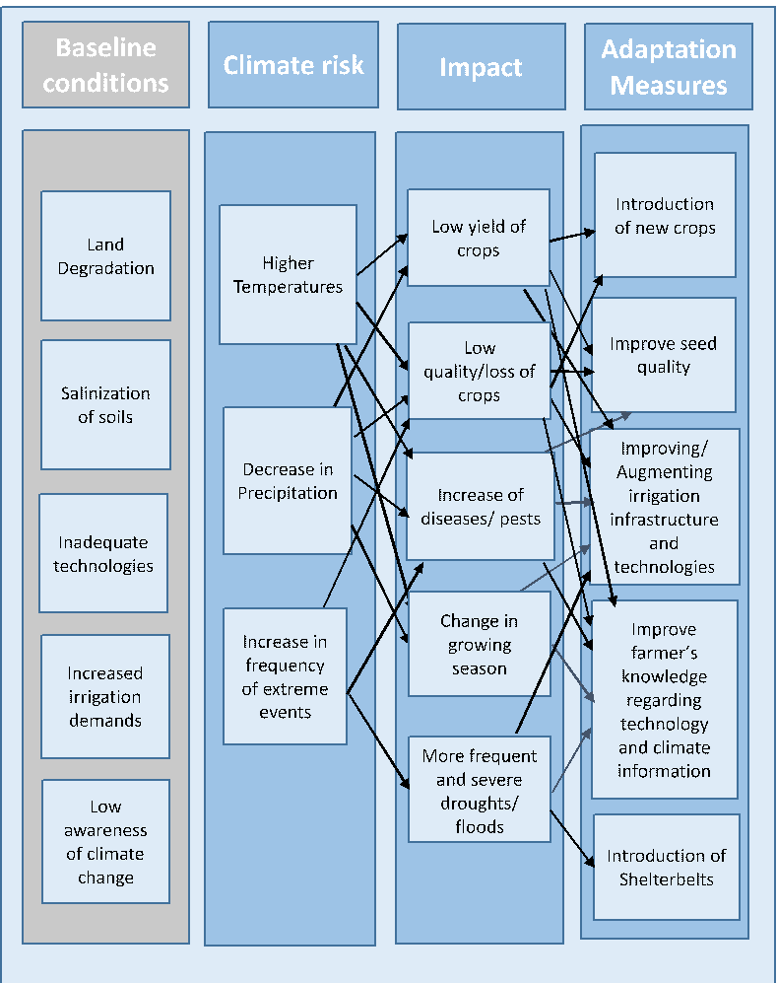
Figure 3.General Adaptation Measures for the Agricultural Sector

The following adaptation measures are expected to be taken to mitigate the impact of climate change and to increase the resilience of the agricultural sector.
- Under current climate change conditions it is required to cultivate new sorts of long vegetation, heat-loving, drought-resistant, and salt-resistant agricultural crops;
- In order to increase the country's food security it is necessary to continue the work of winter wheat breeding.
- The implementation of modern irrigation techniques and technologies, the use of alternative water sources is more appropriate;
- Continuation of the work in breeding, introduction, and implementation of drought-resistant cotton varieties with high productivity;
- Considering the water and wind erosion processes, it is necessary to put forest shelterbelts across the areas, to register eroding and soiled lands, mapping, etc.;
- Establishment of greenhouse farms that meet the needs of the market;
- Establishment of artificial water reservoirs to collect precipitation and use it for irrigation;
- Improvement of irrigation and drainage systems in order to fight against salinization, etc.;
- Rehabilitation of vineyards in the traditional areas and increase the size of vineyards by constructing new terraces in the mountains;
- Restoration of tea plantations in the traditional regions and construction of new gardens in other areas;
- Soil salinization and erosion, continuation and expansion of reclamation measures against drought and white winds;
- In order to increase competitive production development the preparation and implementation of government assistance programs are necessary;
- Establishment of small enterprises for perishable products in rural areas;
Expansion and improvement of existing storage system for agricultural products (storage, refrigerators, etc.).

