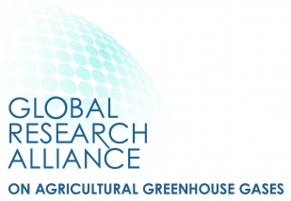

GLOBAL RESEARCH ALLIANCE
Croplands Research Group

NEWSLETTER Nº8, December 2020

- Cropland Research Group GRA Co-Chairs message
- Integrated silvopastoral systems towards a sustainable management
- Climate and environmental change in the Mediterranean basin: current situation and risks for the future
- Pilot study in citrus on the soil and plant improvement from enriched pruning remains to reduce the greenhouse effect (PODA-VAL)
- Agroecology for Europe (AE4EU)
- Special issue on climate change impacts, mitigation and adaptation in croplands
- Upcoming events

1. Cropland Research Group GRA Co-Chairs message

With the difficulties of 2020 behind us, we look to the new year with hope as vaccinations for COVID-19 begin throughout the world. Normalcy will be slow to return, however, and the prospect of resuming in-person meetings seems unlikely for much of 2021. Use of on-line meetings for sharing and discussing our research will continue, and will almost certainly be part of the ‘new normal’ once the pandemic has passed.
This newsletter shares new activities in support of GRA’s core mission, which is to find ways to grow more food without growing greenhouse gas emissions. We start with agroforestry practices in Argentina where novel approaches to integrate livestock with forages and woody perennials are being developed to improve social, economic, and environmental sustainability. Next, the First Mediterranean Assessment Report addressing climate and environmental change and associated risks in the Mediterranean Basin is reviewed, with clear guidance for creating more climate resilient agroecosystems throughout the region. A pilot study looking at the effects of pruning and green manure for citrus crops is reviewed, along with a new and exciting endeavor focused on fostering a transition to agroecological practices throughout Europe through the creation of ‘living labs’. Finally, a publication opportunity for CRG members is shared focused on research reports addressing topics at the nexus of climate change and crop production, along with a list of select meetings and conferences in 2021.
We hope you enjoy reading this issue and wish you the very best in the coming year!

Source: Croplands Research Group Co-Chairs Team, María Rosa Mosquera-Losada, Ladislau Martin-Neto, Mark Liebig.

2. Integrated silvopastoral systems towards a sustainable management

The silvopastoral system (SSP) is an agroforestry practice that intentionally combines woody perennials, forage plants and livestock on the same surface, searching environmental, social and economic stability. Its objective is to establish sustainable production systems. This modality of land use occupies 17% of the world's agricultural surface, especially in tropical regions and is considered one of the 10 best strategies to mitigate Climate Change. The implementation of SSP in Argentina has progressed at different rates in different regions over the last two decades. The main ones are the provinces of Misiones and Corrientes in the northeast (NEA), the province of Neuquén and the Parana River Delta.
In NEA, SSPs have been investigated since the 1990s, with consolidated information on primary production and economic results. This has made it easier for the productive sector to adopt more than 100 thousand hectares of SSP mainly cattle ranches, integrating pines and eucalyptus forestations. As examples, in Misiones, under 7 years old 548 hybrid pine trees ha⁻¹, 9.8 m high projecting 39% shading over combined pasture shrub Cynodon nlemfuensis – Tithonia diversifolia and 680 kg ha⁻¹ cattle stock, 227 kg ha⁻¹ calf production has been obtained, just as the open sky paddocks plus 8 m³ ha⁻¹ of logs. In Corrientes, under similar tree stocking, similar results have been obtained over natural grass lands. However, there is little information on integrated simultaneous production that considers animal production and the impact on the soil carbon (C) balance and greenhouse gases (GHG) in this region. In the Chaco biome (21 million ha), advances were made mainly in the forest and forage components, especially tolerance to shade. In a SSP grown under 85 Prosopis alba tress ha⁻¹ projecting a growing shading from 40% to 60% from age 14 to age 22 years on a Chloris gayana pasture, in spite forage production is 15% higher under open sky paddocks, the animal production under SSP was 15% above (380 kg ha⁻¹) open sky paddocks (330 kg ha⁻¹). It has also been demonstrated that during the hot summer period, cattle under SSP conditions suffers 15 days heat stress versus 30 days under conventional open sky conditions. In these cases, Internal Rate of Return, depending market and management conditions, varies between 3% and 18% annually over 15 – 25 years periods.
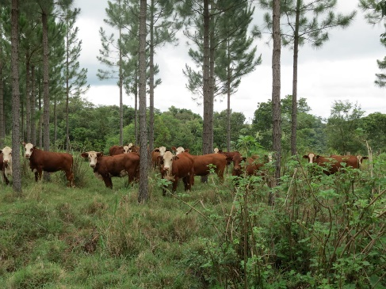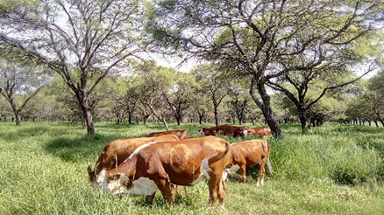
Figure 1: On the left, silvopastoral systems with Pinus hybrid elliottii x Cariabaea – Tithonia diversifolia –Cynodon nlemfuensis -Branford in Misiones and on the right, Prosopis alba - Chloris gayana – Branford in Tucuman in Chaco region.

In other regions, efforts are been made to define integrated models that contemplate animal production at a productive scale. In Andean Patagonia and Tandil (Buenos Aires province), there were developed detailed models of primary production and interactions in the SSPs. Information needs to be generated for irrigated valleys for this region. In the Pampas region and the Delta zone, SSPs development is concentrated in marginal areas for agriculture, and the generation of competitive results and indicators is necessary for this system to be adopted as a productive strategy.
In this sense, the National Institute of Agricultural Technology (INTA), is working throw the structural project "Silvopastoral systems integrated towards a sustainable management", to cover these demands. The main objective of this project is to generate and transfer information and specific technology to contribute to the implementation and proper management of SSP, adjusted to each region, based on forest plantations. The project will strengthen the technical management criteria for the adequate implementation at the regional scale of the SSPs aimed at increasing global productivity and optimizing their profitability and sustainability. Through dissemination and transfer, management strategies will be transmitted to both reduce some issues on productive losses associated with animal health and strengthen added value. It is also incorporating ethical aspects associated with animal welfare. C storage inventories and GHG balance will be established as a productive strategy to mitigate climate change. Also, through the identification of socio-economic-productive indicators in the different regions where they are implemented, it hopes to contribute both to decision making of prospective adopters and the design of public policies to promote SSPs.

Source: Patricia Egolf, Luis Colcombet, Javier Lara, Luis Gandara and Marcelo Beltrán (National Institute of Agricultural Technology, Buenos Aires, Argentina).

3. Climate and environmental change in the Mediterranean basin: current situation and risks for the future

The First Mediterranean Assessment Report (MAR1) prepared by the independent network of Mediterranean Experts on Climate and environmental Change (MedECC) founded in 2015, is now released.
MedECC is an open and independent international scientific expert network acting as a mechanism for decision-makers and the general public on the basis of available scientific information and on-going research. The construction of this network responds to several intentions of regional institutions, such as the UN Environment/MAP through the MSSD 2016-2025 and the Regional Framework for Climate Change Adaptation in the Mediterranean, and the Expert Group on Climate Change of the Union for the Mediterranean (UfM CCEG). MedECC includes more than 600 scientists from 35 countries.
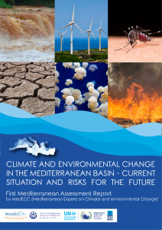
MAR1 assesses the best available scientific knowledge on climate and environmental change and associated risks in the Mediterranean Basin in order to render it accessible to policymakers, stakeholders and citizens. The report includes a Summary for Policymakers (SPM), which comprises the key messages of the MAR1. The report has been written by 190 scientists from 25 countries, all contributing in individual capacity and without financial compensation.

The UNEP/MAP – Barcelona Convention Secretariat, through its Plan Bleu Regional Activity Center, and the Secretariat of the Union for the Mediterranean work in partnership to support MedECC, and to contribute to establish a sound and transparent scientific assessment process. Many other institutions (specified in the “Front matter” and the Annex A of the report) also supported the preparation of this report. The MAR1 is available here.
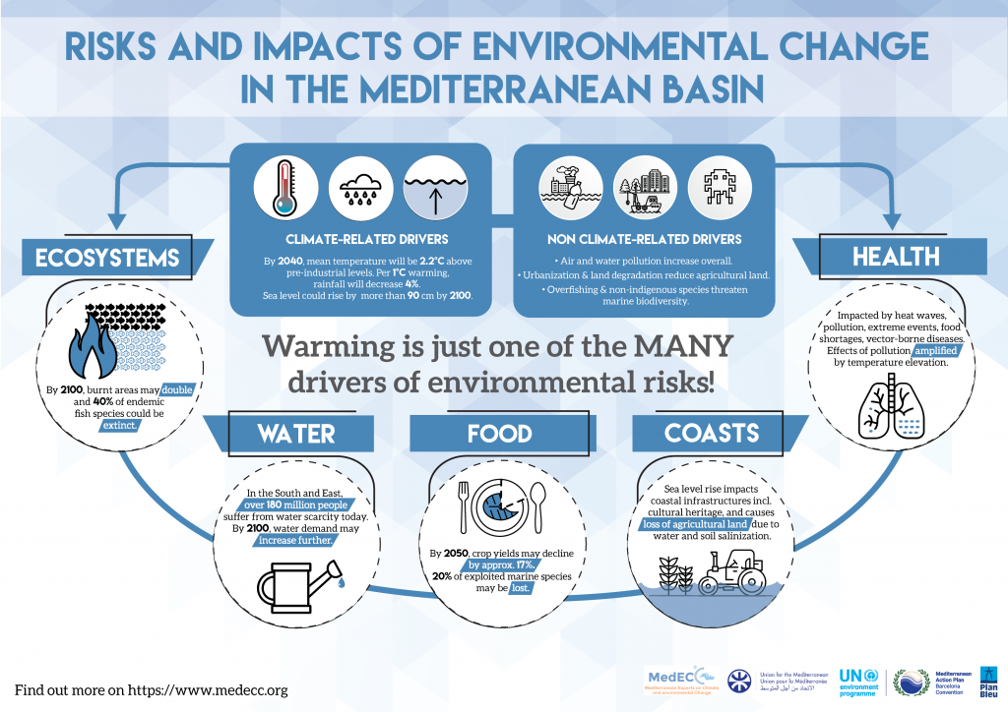
Figure 2: MedECC infographic on drivers and impacts of climate and environmental change in the Mediterranean basin

Source: Mediterranean experts on climate and environmental change, Medcc (https://www.medecc.org/)

4. Pilot study in citrus on the soil and plant improvement from enriched pruning remains to reduce the greenhouse effect (PODA-VAL)

The researchers Rafael Boluda Hernández and Luis Roca Pérez from the SOREiMA research group and Jose Vicente Ros from the REDOLí group, both from the University of Valencia, have received funding from the European Union and the Generalitat Valenciana to develop the PODA-VAL agroecological project. With this project, the benefits of using green manures in combination with pruning remains will be transferred to the agricultural sector as a contribution of biomass to the soil.
Currently, in the Mediterranean region, a large amount of waste from the pruning or stubble of the crops is incinerated, which emits greenhouse gases and causes risks to people’s health and the environment. The proposal developed by the University of Valencia and the Valencian Association of Farmers (AVA-ASAJA) is based on promoting the recycling of pruning remains and promoting green manures or crops that contribute their biomass to the soil before flowering, with which the fungal risk and the appearance of harmful insects is reduced. The application of green manures, made with vegetable crops and pruning remains, produces a significant increase in the production of certain crops.
On the other hand, the incorporation of the plant biomass increases the content of organic matter and favors the fixation of carbon in the soils, which can contribute to mitigate the effect of climate change because soils acts as an important carbon sink on the planet. In addition, avoiding the incineration of stubble and pruning remains and incorporating them into the soil of agro-systems, contributes to the recycling of organic matter and nutrients, to reduce CO₂ emissions into the atmosphere, as well as to the increase in stocks of carbon in the soils. All this helps improve soil quality and mitigate the greenhouse effect.
The project also involves a new approach to the valuation of agricultural waste (citrus pruning remains), which ceases to be incinerated in the fields or transferred to landfills or treatment plants, to carry out the recycling process on site.
The proposal (AGCOOP_B / 2019/017) is funded by the Valencian Agency of Public Works and Agrarian Guarantee of the Valencian Government and by the European Union through the European Agricultural Fund for Rural Development (FEADER).
Project’s website: https://podaval.blogs.uv.es/
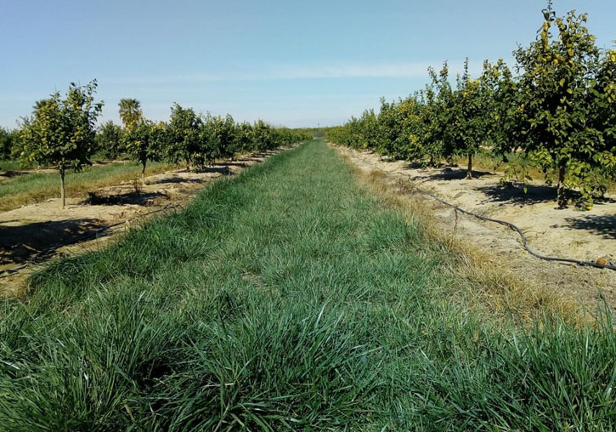
Figure 3: Citrus cultivation with the green cover to be incorporated in the project trials.

Source: Luis Roca (University of Valencia, Spain).

5. Agroecology for Europe (AE4EU)

Last January the new European Union project AE4EU: building a European network on agroecology to accelerate the transition towards sustainable agriculture and food systems was launched. This initiative integrates twelve European partners join force in a coordination and support action to develop a framework for a European network of agroecological living labs, research infrastructure and learning spaces for farmers, research and civil society actors.
European agriculture and food systems is strongly impacted by a large number of challenges including climate change. Agroecology, as a way to design, develop and promote the transition towards biodiversity-friendly, low environmental impacting, and socially just farming and food systems appear as a key approaches to face these challenges.
AE4EU is a three years project, that started in January 2021 and aiming to allow a successful transition to agroecology through a strong development with ambitious and longer-term joint actions at European level in research, innovation, networks, training and education. Thanks to a European network and the involvement of multi-stakeholder partners from different horizons and sectors, the project will analyse agroecology through its different pillars: as a science, a set of practices, and a social movement. The main objectives to cope, among others with climate change from the field are increase connections between relevant actors, while establishing a European Agroecology Exchange Network, develop skills and methods for developing research infrastructure and living labs, prepare funders for increased and complementaty funding of agroecology, improve human and social capital, capacity to tailor policy interventions to specific situations and a strategy, roadmap and a stakeholder network framework for a European partnership in agroecology. The overall goal is to accelerate the transition towards sustainable farming and food systems practices by promoting networking, connectivity and place-based innovation in a co-creative environment.
The Croplands Resarch Group of the GRA will be collaborating in this relevant project through the leadership of the CRG co-chair María Rosa Mosquera-Losada, who leads the policy workpackage where a roadmap and a strategy for agroecology will be launched.
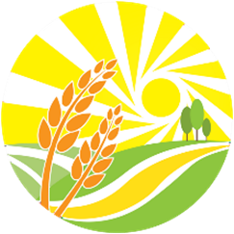
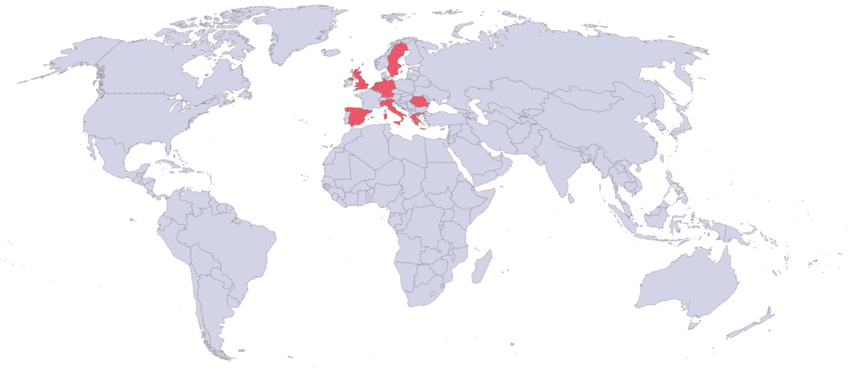
Agroecology for Europe (AE4EU)
Figure 4: In red European countries involved in the AE4EU project.

Source: Maria Rosa Mosquera-Losada (University of Santiago de Compostela, USC, Spain).

6. Special issue on climate change impacts, mitigation and adaptation in croplands

A special issue of the Atmosphere journal will be accepting papers on Climate Change Impacts, Mitigation and Adaptation in Croplands. The Guest Editors of this Special Issue are three members of our Croplands Research Group (Dr. Jagadeesh Yeluripati from The James Hutton Institute, Scotland, UK, Dr. Mark A. Liebig from USDA Agricultural Research Service, USA and Dr. Ayaka W. Kishimoto-Mo from Institute for Agro-Environmental Sciences, Japan).
This special issue welcomes articles addressing relevant topics at the nexus of climate change and crop production. Articles highlighting climate mitigation and adaptation with the delivery of provisioning and non-provisioning ecosystem services are encouraged. Furthermore, articles documenting novel approaches to monitor, model, and upscale environmental change under changing climate for cropping systems across the world are also welcomed as well as contributions describing the development of new and effective technologies that help crop producers mitigate and adapt to climate change.
Manuscripts should be submitted online at www.mdpi.com The paper submission deadline is 30 June 2021. More information here.

Source: Mark A. Liebig (USDA Agricultural Research Service, USA).

7. Upcoming events

Due to the global development of the Covid-19 outbreak, some events were postponed. Please see below the new available dates
Webinar of the Croplands Research Group
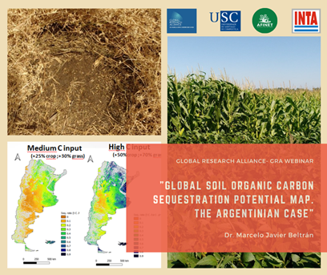 | The Croplands Research Group organizes a webinar titled "Global Soil Organic Carbon Sequestration Potential Map. The Argentinian Case". In this webinar the speaker will be Dr. Marcelo Javier Beltrán from the National Institute of Agricultural Technology-INTA (Argentina). The webinar will take place on 8th March 2021. Please complete the registration form here to follow the webinar.

Global Symposium on Soil Biodiversity
The United Nations Food and Agriculture Organisation (FAO) is hosting a Global Symposium on Soil Biodiversity virtually at its Headquarters in Rome, Italy, during 19th – 22nd April 2021. This symposium will bring together international experts with the aim of reviewing the status of knowledge on soil biodiversity and ecosystem services, the sustainable use and conservation of soil biodiversity, and the contributions of soil organisms to the Sustainable Development Goals (SDGs). More information here.

II World Congress on Integrated Crop-Livestock-Forestry Systems (NEW DATE, VIRTUAL FORMAT)
The II World Congress on Integrated Crop-Livestock-Forestry (ICLF) Systems that was planed to be held in Campo Grande-MS, Brazil, will occur only on virtual format during 4th - 5th May 2021. This congress is an excellent opportunity for exchanging experiences and knowledge as well as updating on the latest research, development, and innovation about ICLF systems around the world. More information here.

5th European Agroforestry Conference (NEW DATE)
The 5th edition of the European Conference on Agroforestry will be held in Nuoro, Sardinia, Italy, during 17th - 19th May 2021. The conference will bring together worldwide researchers, practitioners, policy-makers, public authorities to discuss the role of research and innovation in agroforestry towards the development of a sustainable European bioeconomy, while exploring its potential in fostering environmental, economic and social prosperity. More information here.

17th International Conference on Environmental Science and Technology
The 17th International Conference on Environmental Science and Technology (CEST2021) will be held in Athens, Greece, during 1st - 4th September 2021. This conference is a leading environmental conference where top experts, scientists, entrepreneurs, representatives of public administration and social initiatives present state-of-the-art research on current and emerging environmental issues. More info here.

18th International RAMIRAN Conference (NEW DATE)
The 18th International RAMIRAN Conference will be held in Cambridge, UK, during 20th – 23rd September 2021. The conference will focus on developing strategies to maximize the efficiency of organic materials against a background of changing regulation, policy, and market forces, as well as increasing pressure on the environment, soil quality, and food production. More information here.

14th European Farming Systems Conference (NEW DATE)
The 14th European Farming Systems Conference (IFSA – European Group) will be held at the University of Évora, Portugal, and hosted by the Institute of Mediterranean Agricultural and Environmental Sciences during 10th – 14th April 2022. The main focus of this years’ conference will be Farming Systems Facing Climate Change and Resource Challenges. More information here.

2nd International Symposium on Climate-Resilient Agri-Environmental Systems
The 2nd International Symposium on Climate-Resilient Agri-Environmental Systems (ISCRAES 2022) will be held in Dublin, Ireland, during 24th – 27th May 2022. The main theme of this symposium is “Implementing the New Green Deal: The Path Towards Sustainable Agriculture“, which refers mainly to European Green Deal having the opportunity and resources to achieve the primary objective of a sustainable Europe and planet by tackling the current major environmental, climate, and societal challenges facing by the world. More information here.

4th Agriculture and Climate Change Conference (NEW DATE)
The 4th Agriculture and Climate Change Conference will be held in Dresden, Germany in 2022 (date will be announced soon). The Conference will focus on the likely impact of climate change on crop production and explore approaches to maintain and increase crop productivity into the future. More information here.

This is your newsletter! If there’s anything you think should be included, please send suggestions to mrosa.mosquera.losada@usc.es for the next issue
Editors-In-Chief: Nuria Ferreiro-Domínguez and María Rosa Mosquera-Losada
Editorial Committee: Ladislau Martin Neto, Mark Liebig, Anastasia Pantera

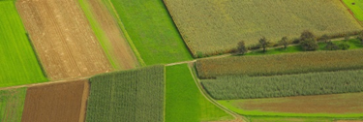 | Sign up to Receive Croplands Research Group Newsletters | Global Research Alliance  globalresearchalliance.org

