

The Rumen Microbial Genomics Network (RMG) is a forum for researchers who utilise genomics approaches to comprehend enteric methane emissions and the means by which these might be reduced without compromising animal health or productivity.The objective of the RMG 2025 Workshop is to convene experts and participants from diverse fields of rumen microbiota to explore cutting-edge topics and to facilitate knowledge exchange in a collaborative environment.With a focus on interactive discussions, the workshop promises to provide valuable insights and to foster connections among professionals.

The workshop is scheduled to take place at the Oceania hotel, situated at 82 Bd François Mitterrand, 63000 Clermont-Ferrand.

RMG chairs would like to extend our sincere gratitude to **Nanjing Agricultural University** for their generous sponsorship of this workshop.

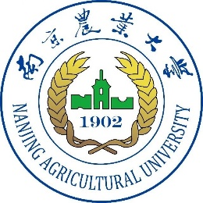

Programme:

14h30 – 14h35: Welcome

14h35 – 15h05: **Rumen adapted for future feeds to improve animal health and performance**. **Nikola Palevich**

15h05 –15h35: RMG community contributions

15h35 – 16h00: coffee break

16h00 – 16h30: **Efforts to mitigate enteric methane emissions from ruminant livestock by directed manipulation of the rumen microbiome Robert Gruninger**

16h30 –17h00: RMG community contributions

17h00 - 17h30: **Regulation of rumen metabolism to improve the feed efficiency and reduce methane emission Yanfen Cheng**

17h30: Closing remarks

Registration : <https://gutmicrobiology-2025.symposium.inrae.fr/rmg-network>